**INDEX**

**THE PROJECT** ---------------------------------------------------------------------------------------------------------- 02

**theKeyFACT website** ---------------------------------------------------------------------------------------------------- 02

**DESIGN CHOICES** ----------------------------------------------------------------------------------------------------- 03

**Combining two different methods** --------------------------------------------------------------------------------- 03

**Translating design into code** ----------------------------------------------------------------------------------------- 05

**Media queries** ------------------------------------------------------------------------------------------------------------ 06

**The use of containers** -------------------------------------------------------------------------------------------------- 07

**Menu and navigation methods** -------------------------------------------------------------------------------------- 08

**CSS styling classes** ------------------------------------------------------------------------------------------------------- 08

**Visual Identity** ------------------------------------------------------------------------------------------------------------ 09

**CODE VALIDATION** -------------------------------------------------------------------------------------------------- 10

**FINAL CONSIDERATIONS** ----------------------------------------------------------------------------------------- 11

**THE PROJECT**

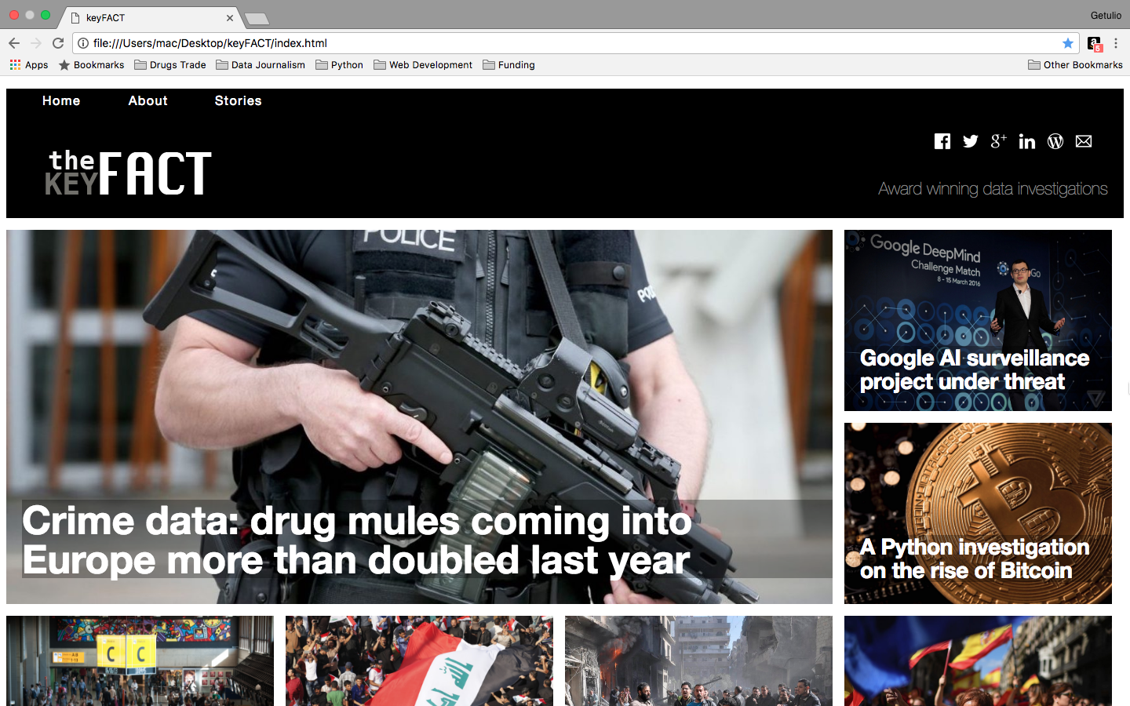

**Figure 1**

**theKeyFACT website**

This coursework departs from an idea for a website on journalistic data investigations, with a main *index.html* page to highlight story headlines, which are all hyperlinked to the same secondary page named *post_page.html***.**

Thus, the *post_page.html*is used for displaying full content, which is interconnected to the main page by anchors for quick access of seven related stories.

In addition, there is a page named *about.html* displaying information on the idea behind the website and a form for newsletter subscription (not yet coded for retaining input).

The website **KeyFACT** developed for this assignment is intended to showcase abilities in CSS and html during self-study and in-class practice. For this particular reason, the code behind the whole structure does not use aid from Bootstrap or any other web design framework platforms.

**DESIGN CHOICES**

**Combining two different methods**

**TheKeyFACT** uses the well-established grid concept of dividing the screen in 12 columns for precise positioning of elements, more rational use of space, and to facilitate inclusion/exclusion of visual elements without compromising other areas of layout.

The starting point of this project follows some of the principles of graphic design that have been incorporated into mainstream web design[1].

This relates to the positioning, scaling and proportioning of the visual elements in hand-draw design first, followed by a design in Adobe Illustrator or equivalent software with the intention of calculating exact measurements.

Proportions were established with a series of trials that are demonstrated in the following pictures, with several attempts to map blank space areas to be used within the design.

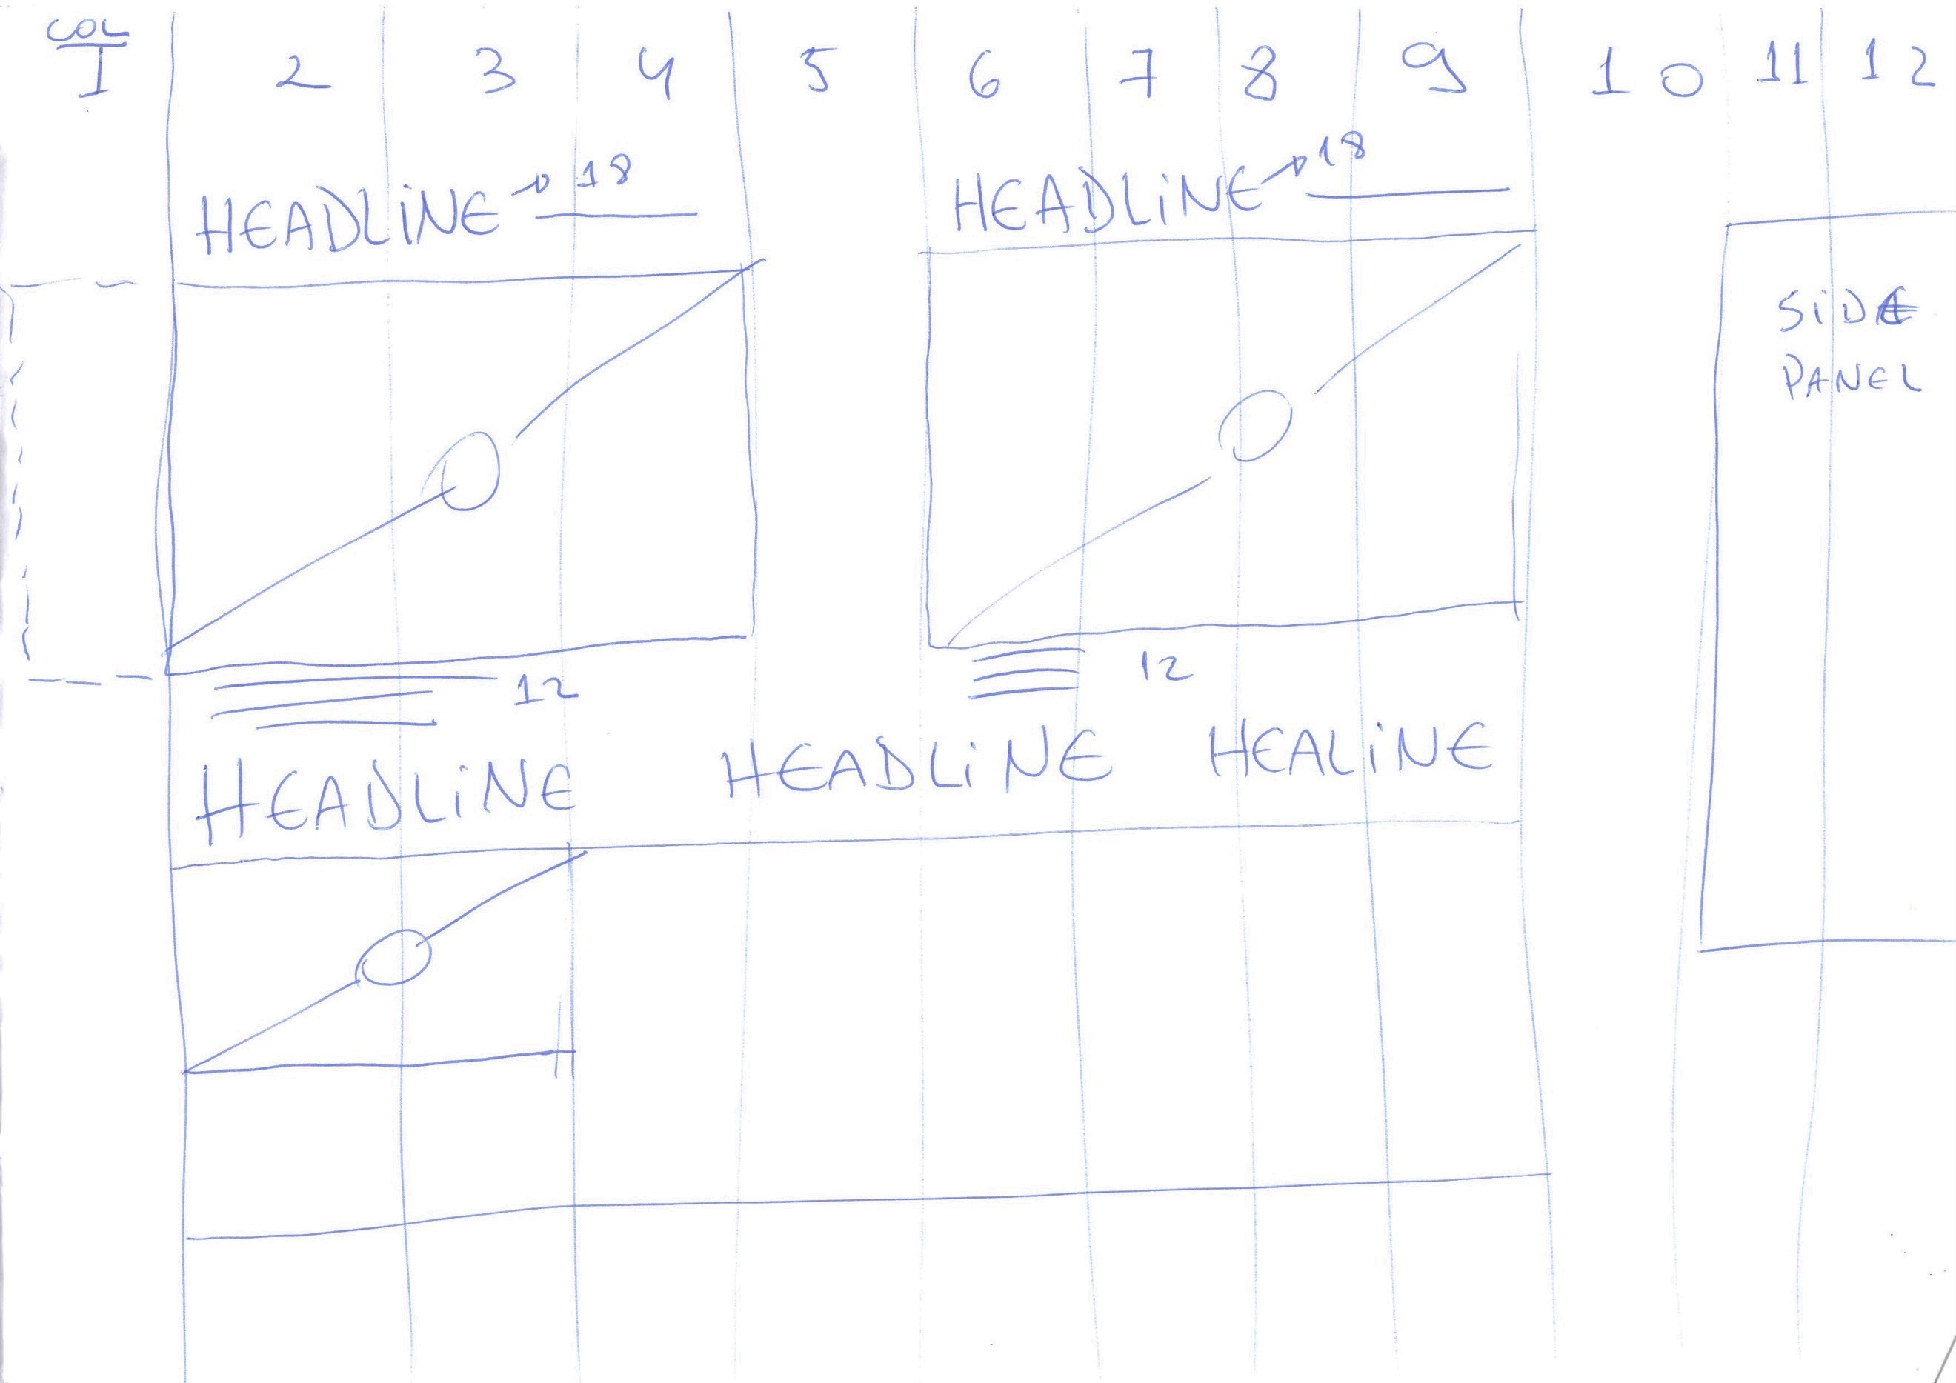**Figure 2**

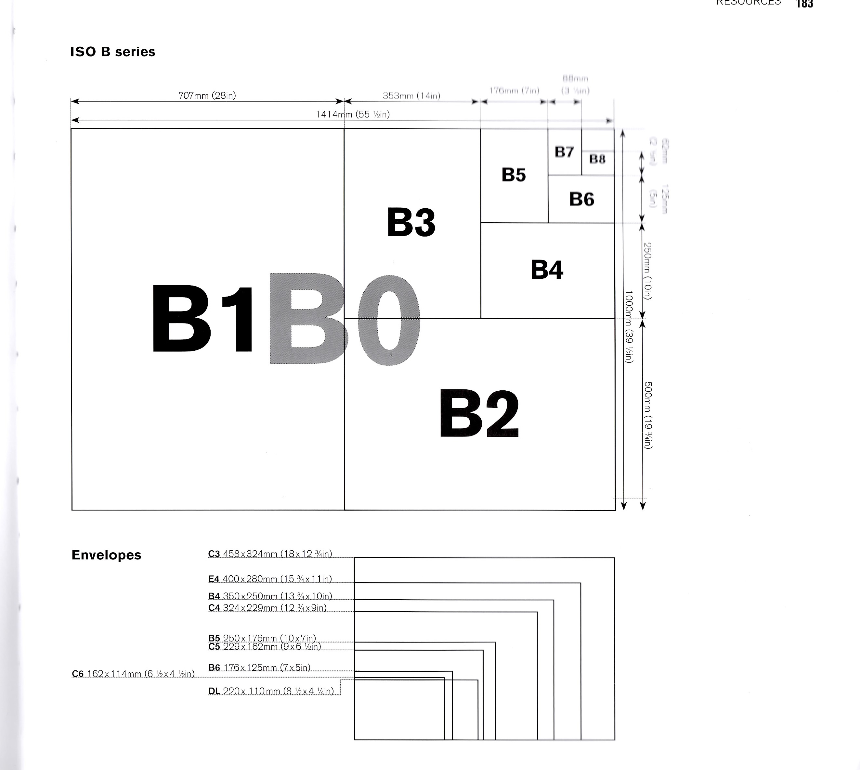**Figure3**

In **Figure 2** the first attempt to

give some design coherence to **index** page,

following principle of scaling from the

*Graphic Design School,* **Figure 3**.

Below, in *figure 4 e 5,* the first drafts of *post_page*and*index*pages with scaling in percentages and marked items for later correction. The precision achieved using these scaling attempts can be seen in the final product.

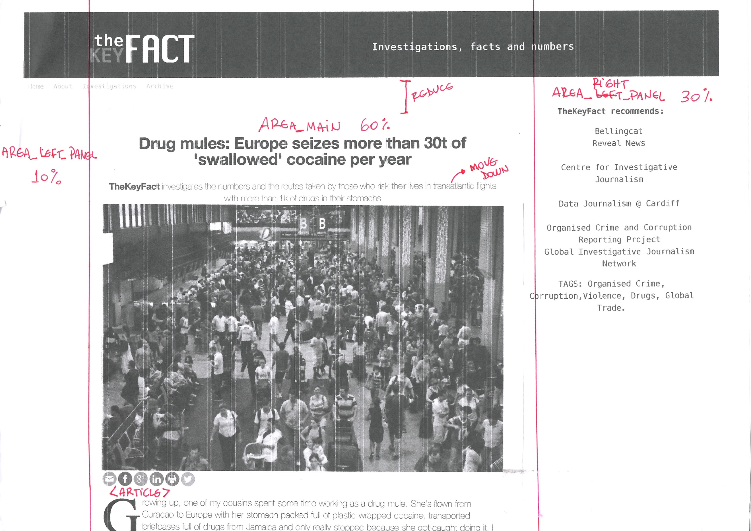 **Figure 4**

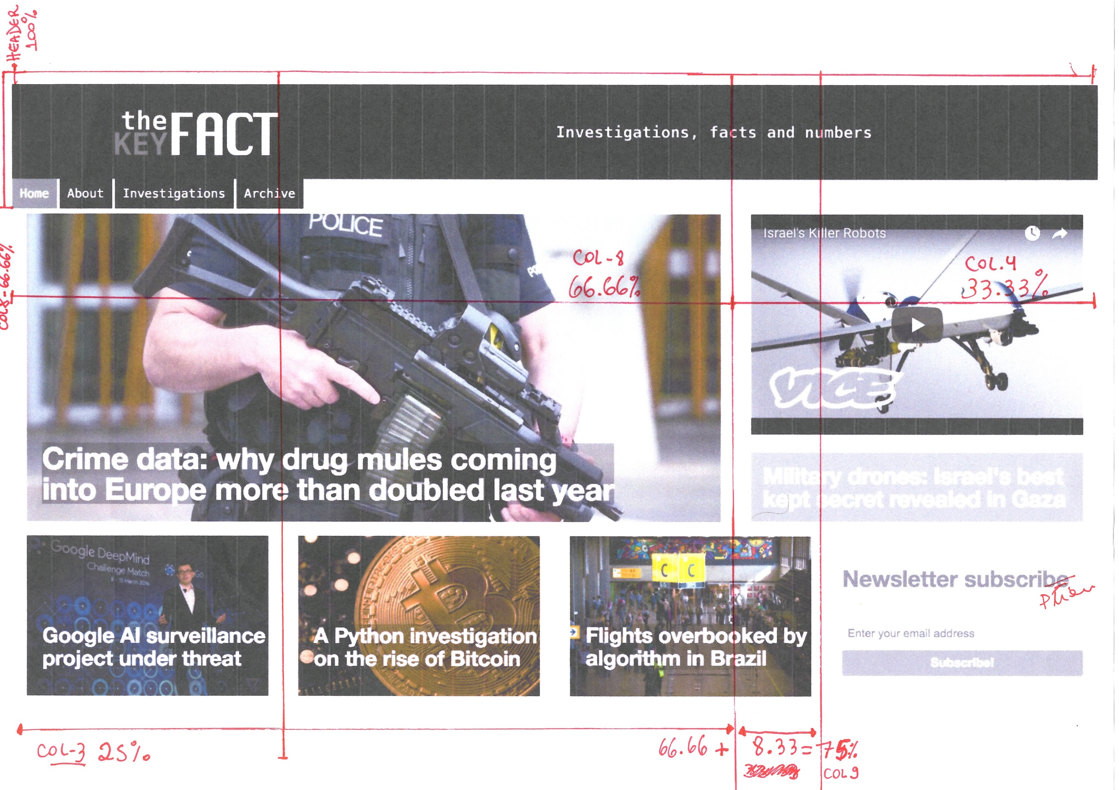**Figure 5**

**Translating design into code**

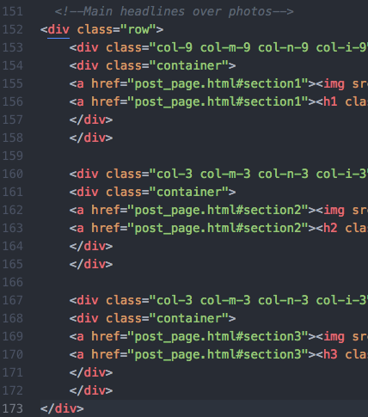With well-defined grid measurements, work on coding began by nesting elements in *columns*, *rows* and *containers*, leaving items together only if they would behave well to changes in resizing.

Therefore, a column (col-9) with 60% of screen size, together with another (col-3) of 40%, were the first to be created inside a *row,* housing three photo-containers with headlines over images - *see figure 6.* Underneath the first *row*, a second *row* was scripted later, containing four other columns of 25% each, with text headlines over pictures also set as containers. A third *row* was incorporated later, to house an *iframe* video element and text. **Figure 6**

The header element was also set as a container with 100% width, with nesting space for website menu, slogan, a logo (created in Adobe Illustrator with a transparent background and sized to adjust well with other elements), and images for the share buttons. The footer was set in the same way to contain the copyright signature and a JavaScript API a for PayPal checkout button for donations (the only part of the code coming from a third party).

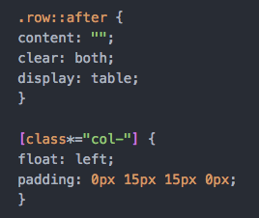As the **iframe** element for YouTube videos did not respond well to resizing, it was removed from main layout area on the index page, being relocated to the bottom of the page in another row sided with a second column containing only text. This positioning allowed the iframe element to be made invisible more easily by a query, avoiding blank spaces during reframing – *see Figure 1 and 5 for comparison*.

**Figure 7**

In order to maintain these rows and columns grid system in place, the *floating left* and c*lear fix* principles were applied automatically to all the design, following the code seen in *figure 7*. The same piece of script maintains a 15px padding in between internal spaces of the grid.

**Media queries**

The first hand-drawn design idea for the **index** page was translated into html and CSS code using the total area of a large laptop screen of **1440 x 900px** and then scaled down to five different breaking points, with re-scaling of font sizes and hiding of elements, where appropriate, within the intervals:

* 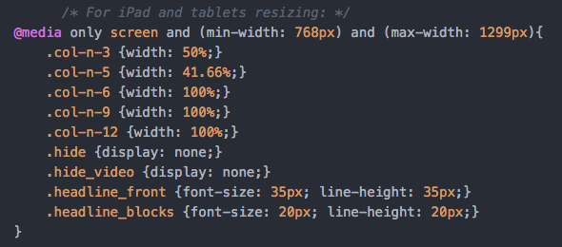**0px to 599px** (Small to medium mobile phones)
* **600px to 767px** (Large **mobile to tablets)**
* **768px to 1309px** (iPads and large tablets)
* **1310px to 1439px** (Normal desktop screens) **Figure 8**
* **Over 1440px** (Large desktop screens)

In *figure 8*, one of the media queries is highlighted for its precision in targeting not just column sizes, but also for hiding elements such as, in this case, a **video** and the **slogan** from the page, when dimensions fall within the 768px to 1299px interval. The query also targets font sizes for appropriate scaling.

Another important part of the code scripting was to maintain resizing within the parameters of devices being used. For this reason, the following meta script line is maintained in all pages:

**<meta charset="utf-8" name="viewport" content="width=device-width, initial-scale=1.0">**

In the other two pages (*about* and *post_page*) the use of media queries produces less visible changes when scaling. However, the five thresholds of resizing are maintained for maximum precision in case of more content being added later. This can be especially noted within the limits of a small screen of about 320px.

**The use of containers**

The resizing of the elements inside of the header, footer and headline images was particularly complex, as it had to account for the hiding of elements and perfect positions of **text**, **logo**, **menu** and **share buttons,** done with appropriate **padding** and use of **containers.**

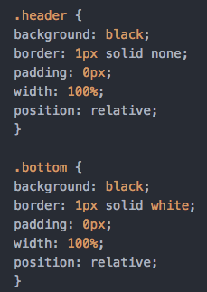 **Figure 9**

**Figure 10**

In **Figure 9, 10 and 11,** logo, menu and share buttons alignment was only possible with the use of containers. A media query has also hidden the website slogan to avoid images and text overlapping. Containers were extensively used to position text within images as seen in the index page headlines.

**Figure 11**

**Menu and navigation methods**

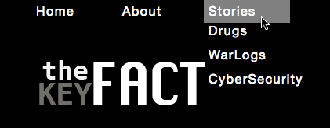One of the main design features of **KeyFACT** is its navigation menu/submenu built with simple code, scripting a list nested within another list. The option for a simple design avoids the use the *hamburger* practice on purpose. This follows a recent trend in web design to avoid hiding menus even in smaller devices, to favour user engagement and accessibility[2].

Therefore, the website navigation bar is maintained fully visible in all device sizes *– see figure 12.*

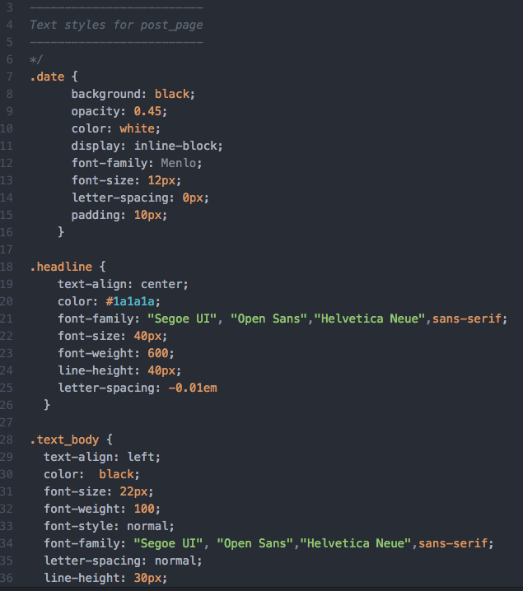**Figure 12 Figure 13**

**CSS styling classes**

The website object of this assignment has a great number of classes, largely because of the differences in typography, colours and sizes throughout all pages. An effort has been made to create main classes, grouping some of the major styles as per: *date, headlines, sub-headlines, text body* among many other classes. The general styling attributes can be seen in the *figure 13*, and may include: opacity; font-family; font-size, colour, background colour, among others.

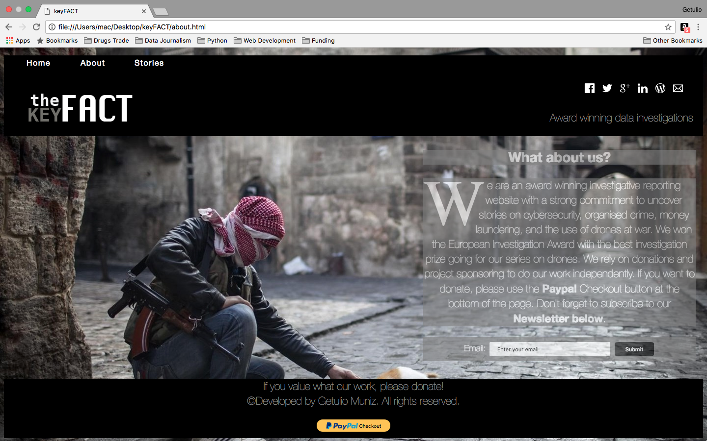 **Figure 14**

**Visual Identity**

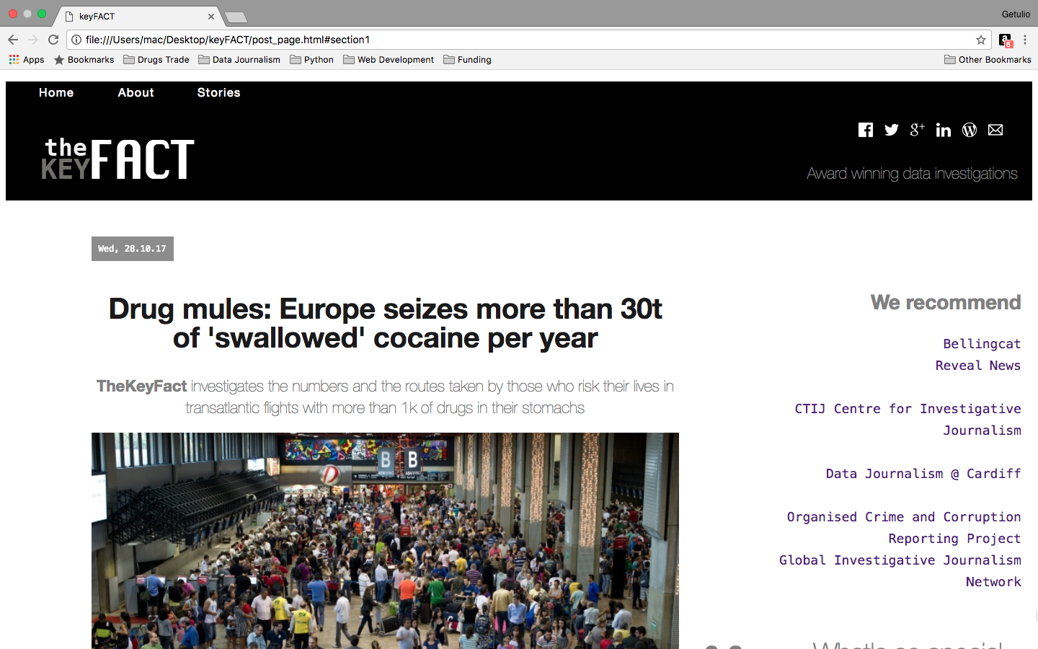Although the three pages ended up varying widely in styles, they retain the same visual identity with use of the identical typography and colour scheme. Three main style sheets were created inside the CSS file, dividing groups as **index**, **about** and **post_page**. Comments in the CSS script mark the appropriate groupings. What gives the whole website a distinctive unity is the use of the exact colour scheme **black/gray/white** and **Segoe UI Open Sans** fonts throughout. Not allowing any other colours or font styles into design is one of the key principles in visual identity practices followed in this assignment (Dabner, 2010). The *about* page seen in *figure 14*, for example, uses a completely different approach to background and text over images (no containers were used), and yet still retain the same visual coherence to the rest of the website, as in the post_page in *figure 16.*

**Figure 16**

**CODE VALIDATION**

All of the three pages were fully validated by the W3C validator. In order to get a final result with zero errors and warnings, some corrections had to be made.

The main issue found at the first validation attempt was related to meta scripting, which highlighted that the attribute “http-equiv” and “name” was not working at a particular point. After consulting various forums online, the W3C recommendation was used to write meta scripts to correct the error – the code used in all three pages can be seen in *figure 17.*

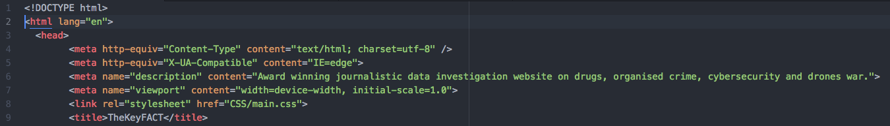**Figure 17**

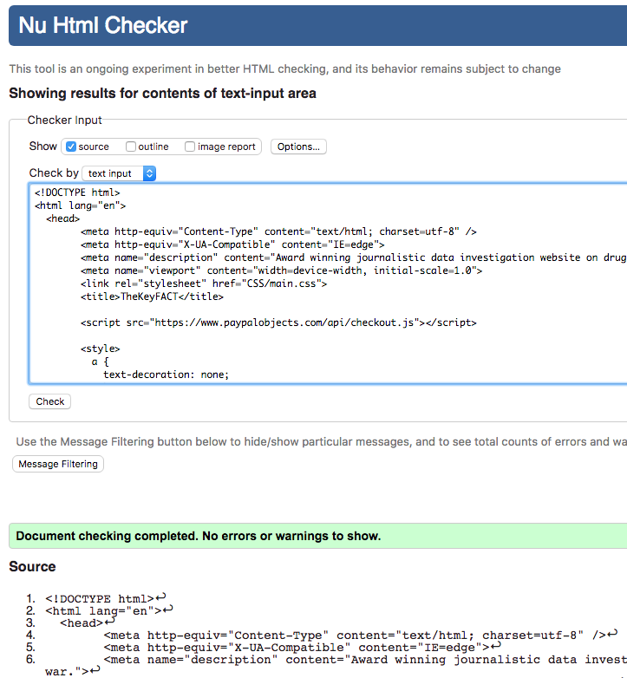All the issues corrected on *post* or *about* pages were related to <div> and/or <ul> elements not closed properly. They have been all addressed for full validation with no errors or remarks as seen in *figure 18.*

**Figure 18**

An effort has been made to use the **<article>** element in the post_page, following the W3C guidelines to allow syndication and distribution or material independently, as theKeyFACT website may well be published in the future.

All the <h1> and <h2> elements were used appropriately for ordering of items in CSS cascading. The <section> element was not used in the post_page in favour of more specific tags.

**FINAL CONSIDERATIONS**

This assignment has brought an incredible new knowledge in CSS and html, and it was truly enjoyable throughout. The whole process seemed quite complex at times, but the knowledge obtained in class and the worldwide *html* and *CSS* community of coders were of immense help, particularly the Stack Over Flow, the W3C guidelines, Mozilla Development Network, W3 School forums and guidelines.

As this project is intended to be continued, new approaches and methods will be needed to elevate the website to a truly user experience design level. However, the foundation and some basic principles are already incorporated in this design.

1. Dabner, David. *Graphic Design School*. London: Thames and Hudson. Print.
2. Constine, J. <https://techcrunch.com/2014/05/24/before-the-hamburger-button-kills-you/>